WISHWAVE

Software Architecture Document

Version 1.0

Revision History
Date | Version | Description | Author
28/11/2024 | 1.0 | Complete the final version | Tran Thi Giang,  Dang Thi Khanh Chi,  Le Minh Hang,  Nguyen Thi Mai Phuong,  Cao Huu Quang,  Phan Thuy Ngan

Table of Contents
1. Introduction 4
1.1 Purpose 4
1.2 Scope 4
1.3 Definitions, Acronyms, and Abbreviations 4
1.4 References 4
1.5 Overview 4
2. Architectural Representation 4
3. Architectural Goals and Constraints 5
4. Use-Case View 6
4.1 Use-Case Realizations 6
5. Logical View 18
5.1 Overview 18
5.2 Architecturally Significant Design Packages 19
6. Process View 19
7. Deployment View 19
8. Implementation View 19
8.1 Overview 19
8.2 Layers 19
9. Data View (optional) 19
10. Size and Performance 19
11. Quality 20

Software Architecture Document

Introduction

Purpose
The purpose of this Software Architecture Document is to provide a comprehensive architectural overview of the "WishWave: E-commerce Platform" system, using a number of different architectural views to depict different aspects of the system. It is intended to capture and convey the significant architectural decisions which have been made on the system.

Scope
The Software Architecture Document applies to the development and implementation of the "WishWave: E-commerce Platform". It outlines architectural goals, identifies stakeholders and their concerns, specifies patterns and styles, defines components/modules, details data management, illustrates deployment, addresses security, considers scalability/performance, lists the technology stack, and identifies integration points. This document serves as a roadmap for developers and stakeholders, ensuring a clear understanding of the system's architecture and guiding its implementation.

Definitions, Acronyms, and Abbreviations
User - a person who uses the system.

References
NA.

Overview
As the cornerstone of the WishWare System's development, this document is structured to provide insights into various architectural perspectives. It covers details like architectural representation, goals and limitations, and use case realizations. The subsequent sections further dive into the specific aspects of the system from four main perspectives-logical, process, development, and implementation. Additionally, this section provides insights into data views and performance, along with considerations related to quality perspectives.

Architectural Representation
This document presents the architecture as a series of mandatory views: Use-Case View, Logical View, Deployment View, and Data View. These views are presented as StarUML and use the Unified Modeling Language (UML).

Use-Case View
- Audience: all the stakeholders of the system, including the end-users.
- Area: describes the set of scenarios and/or use cases that represent significant functions in the system.
- Related artifacts: Use-Case Model, Analysis Model, and Use-Case-Realization documents.

Logical View
Audience: designers, programmers, testing staff.
Area: functional requirements: describes the design’s object model.
Related artifacts: Design Model.

Deployment View
- Audience: deployment managers, system administrators
- Area: topology: describes the mapping of the software onto the hardware and shows the System distributed
aspects.
- Related artifacts: Deployment Model.

Data View
- Audience: data specialists, database administrators.
- Area: persistence: describes the architecturally significant persistent elements in the data model.
- Related artifacts: Data Model.

Architectural Goals and Constraints

Architectural Goals:

Scalability: The platform's architecture should be able to accommodate a growing number of concurrent users and transactions without affecting performance or system availability. It must scale efficiently as user traffic and product listings increase.

Security: The system architecture must prioritize the security of user accounts, payment details, and transaction data. This includes implementing strong encryption, secure authentication, and authorization protocols to protect against unauthorized access, data breaches, and fraudulent activities.

User Experience: The architecture should be designed to deliver an intuitive and seamless shopping experience. It must support a responsive and fast-loading interface, easy navigation, quick checkouts, and personalized features like tailored product recommendations and notifications to enhance user engagement.

Architectural Constraints:

Performance: The system should meet defined performance benchmarks, including fast response times, high throughput, and optimized resource usage. This ensures a smooth shopping experience, even during peak traffic periods, with minimal delays or slowdowns.

Compliance: The platform must comply with relevant industry regulations, including data privacy laws, payment security standards, and consumer protection laws. This ensures the platform operates legally and protects user information in line with global and local regulations.

Maintainability: The architecture should be modular, with well-structured code and clear interfaces, to allow for easy updates, bug fixes, and ongoing maintenance. Automated testing and deployment systems should be in place to ensure software quality and minimize downtime during updates.

Use-Case View

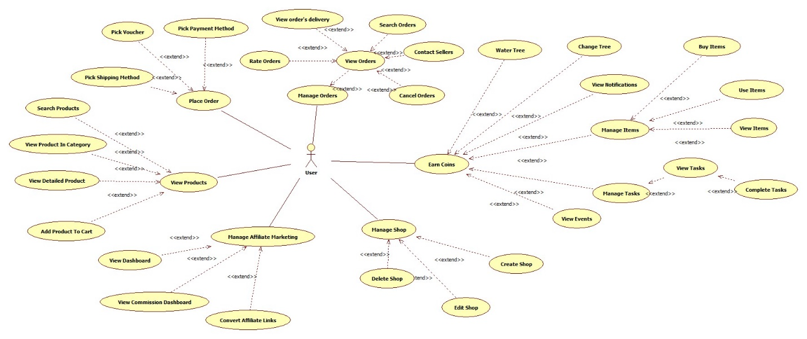

Use-Case Realizations
View Products
Use-case | View Products
Scenario | Processing view product activities by WishWave users.
Triggering events | User accesses the WishWare system.  User clicks on the product search bar.  User choose sort and filter options.  User choose a product to view details.  User clicks “Add to cart”  User clicks “Buy Now”  User clicks add to wishlist icon.  User clicks “Reset Filter”  User clicks “Reset Search”
Brief description | This use case outlines the steps involved in browsing for a product using the WishWare website.
Actors | User
Related Use Case | None
Preconditions | The user has registered an account with the WishWare system.  Users must have an active internet connection.
Post conditions | The system displays the available products based on the user's search criteria.  The system displays the screen showing the product successfully added to the cart.  Users can review and select a product to buy.
Flow of events | User accesses the WishWare platform and loads the Homepage screen. User clicks to choose a category the user wants. The request will be sent to HomeManager and then the product list from the ProductEntity model will load and show the HomePage which displays a list of products and sort as well as filter option. User selects sort, filter options such as shipping from, rating, and price range so the screen can show products that match the user's selection.  If user clicks on the search bar to find product, the SearchManager processes the request by querying the ProductEntity. Then user can select sort and filter options like the above.  User chooses a product to view details and loads the ProductDetailsPage screen. The request will be sent to ProductManager and then get data on the product from ProductEntity. User can add products to cart or wishlist are managed by the CartManager or WishlistManager, which updates the CartEntity or WishlistEntity.
Exception conditions | No search results:  If the search for products yields no results based on the specified criteria, the system displays a notification indicating, "Uh oh. We did not find products. Try again."  Users can adjust their search parameters and initiate a new search.  Connection issues:  In case of network or server issues during the product browse process, the system presents a notification stating, "Unable to display product information at the moment due to connection issues. Please check your internet connection and try again."  Users can verify their internet connection and attempt the search again.

Place Order
Use-case name | Place Order
Scenario | A user purchases products in their shopping cart, enters shipping details, selects a shipping method, applies a voucher if available, chooses a payment method, and confirms the order.
Triggering events | The user clicks the "Buy Now" or "Proceed to Checkout" button on the Shopping Cart page.
Brief description | This use case describes the process of completing a product purchase. It includes collecting shipping information, selecting a shipping method, applying vouchers, choosing a payment method, verifying payment, and confirming the order.
Actors | User (customer placing the order).
Preconditions | The user is logged into the system.  The user has selected products in the shopping cart.  The system has product details available (e.g., product name, price, quantity, stock status).
Post conditions | The order is successfully created, and the user is redirected to the Order Tracking page.  Payment is confirmed, or the system records the selected payment method for COD.  Shipping and billing details are saved for future reference.
Flow of events | The user clicks "Buy Now" on the Shopping Cart page.  - The system retrieves the product bill details and displays the Checkout Interface (CheckoutUI).  - The user fills in the shipping details (name, phone number, address).  - The system validates the shipping information:  - If valid, the details are saved.  - If invalid, the system displays an error message, and the user must correct the input.  - The system suggests a default shipping method and calculates the order cost.  - The user can:  - Accept the suggested shipping method.  - Select an alternative method (if available).  - The system updates the order summary, including product details, shipping costs, and total amount.  - The user optionally applies a voucher.  - The system validates the voucher and recalculates the order cost if valid.  - The user selects a payment method:  - WishWavePay Wallet: The system checks the wallet balance.  - ATM Card: The user enters card details, which are validated by the system.  - COD: No additional action is required.  - The user reviews the order summary and confirms the order.  - The system finalizes the order, initiates the payment (if applicable), and redirects the user to the Order Tracking page.

Manage Orders

Use case name | Manage Orders
Scenario | Processing view orders activities by WishWave user
Triggering event | Loading page Main orders  User view main oders  User click on “To Pay” button to see pending payment orders  User click on “To Ship” button to see shipping orders  User click on “To Receive” button to see receive orders  User click on “Completed” button to see completed orders  User click on “Cancelled” button to see cancelled orders  User click on “Return Refund” button to see return refund orders
Brief description | The use case allow user view orders on the system
Actor | User
Relate use cases | Login  Chat Connect
Preconditions | Available account
Post conditions | User have at least one valid account to login and then user can view orders
Flow of events | The user begins managing orders by loading the MainOrders page. The system retrieves data for all orders from the OrdersManager, and the orders are then displayed on the MainOrders interface. Here, the user can view all orders or choose the search option in the search bar. The user enters an OrderID to look up specific orders, and the results are displayed on the MainOrders screen.The MainOrders interface includes a navigation bar, where users can click on navigation items to view order statuses such as All, To Pay, To Ship, To Receive, Completed, Cancelled, and Return Refund.  If the user wishes to view orders waiting for payment, they click "To Pay" on the navigation bar. This request is sent to the OrdersManager to fetch payment-pending orders, which are then displayed in the PaymentUI interface. Here, if the user selects the "Cancel Order" option, a cancellation reason form is displayed. The user selects a reason, and the canceled order is subsequently shown on the CancelledUI screen.  To access orders currently in shipping, the user clicks "To Ship" on the navigation bar. A request is sent to the OrdersManager to query the list of orders. If there are shipping orders, they are displayed on the ShippingUI interface, where the user can tap the "Contact Seller" button to reach the seller via the ChatUI interface, as described in our Chat Connect use case.  If the user wants to view orders awaiting delivery to the recipient, they click "To Receive" on the navigation bar. The system requests the list of such orders from the OrdersManager. These orders are displayed on the ReceiveUI interface, where the user can select the "Delivery" button to track the shipment. At this point, the ReceiveUI interface shows the delivery route and estimated delivery time.  For completed orders (successfully finalized transactions), the user clicks "Completed" on the navigation bar. Data for these orders is retrieved from the OrdersManager. If there are completed orders, they are displayed on the CompletedUI interface, where the user can click the "Rate" button to provide feedback on the completed order. A rating panel is displayed, allowing the user to rate their satisfaction on a scale from 1 to 5 stars.  To view canceled orders, the user clicks "Cancelled" on the navigation bar. The system retrieves data for canceled orders from the OrdersManager and displays them on the CancelledUI interface. Here, the user can review orders canceled during payment-pending status or revisit previously canceled orders.  If the user wants to view returned and refunded orders, they click "Return Refund". A request is sent to the OrdersManager to retrieve the data. The returned orders are displayed on the ReturnUI interface, allowing the user to review their previously returned orders.
Exception conditions | None

Manage Shop
Use-case name | Manage Shop
Scenario | When customers have a demand to start their own business on WishWave, they start creating their shop on the platform. After entering required information, users begin the managing process.
Triggering events | 1. The user selects the "Add Shop" button within the Shop Manager page when it is still empty.  2. The system detects the user's intent to create a shop and initiates the shop creating process.
Brief description | The use case shows the user's steps of creating, editing and deleting a shop on the WishWave platform.
Actors | Event attendee (Users)
Preconditions | - The user must be registered and logged into the WishWave platform.  - The user has access to required details for each function (e.g., shop details for Add/Create).  - The user has a compatible device for identity verification where necessary.
Post conditions | - Shops are successfully added, created, edited, or deleted as per the user’s actions.  - All changes are saved and accessible within the user’s account for future reference.
Flow of events | First, after accessing the Shop Manager interface, if the user has not created any shop, the screen will display, "There is no shop here yet! Click 'Add Shop' below to add your new shop" with an Add Shop button in the lower right corner; the user clicks on this button to start the process of creating a shop.  When entering the Add Shop page, the screen will display a request for the user to enter the first 2 basic pieces of information, which are the store name as well as the store's contact phone number. After entering the above 2 pieces of information, the user clicks on the Next button in the lower right corner to start the Create Shop process.  The Create Shop process will include many steps. First, after obtaining 2 pieces of information from the Add Shop section, the user will continue to fill in the information; the interface will display 2 pieces of existing information that cannot be edited anymore, along with 2 new pieces of information: delivery address and contact email. After entering all the information, the user continues to click the Next button to continue to the next step—choosing the delivery method. At this time, the interface will appear, listing WishWave's current delivery methods. All of the above methods are in an unselected state; the user needs to move the cursor to the switch in the same box as the delivery method to select the desired delivery method. After selecting, the user continues to click Next to go to the next step—entering tax information. The screen will now display 4 main pieces of information: business type, business registration address, email, and tax code. All information is entered in the form of a text box, except for the Business type section, where the user needs to choose between 3 methods: individual, household, and company. After selecting and entering the information, the user clicks Next and goes to the final step—verifying the information. A reCAPTCHA box will now appear on the screen, requiring the user to enter and verify the information. After completing verifying, the screen will have 2 cases: If the information is successfully verified, the screen will notify this success and require the user to press the Proceed button to return to the Shop Manager interface, but if the verification information fails, the user will be asked to press Try Again to return to the Add Shop process and start over.  With a store in operation, the Shop Manager interface will now be a dashboard screen with a lot of different information related to the store's business operations. On this interface, with the store name in the upper left corner, in the same row as it but on the right will be 2 options, including Edit and Delete Shop. When the user presses Edit Shop, the interface will be taken to the Shop Information section. Unlike when the store has not been created—also known as Create Shop—now all 4 pieces of information in the Shop Information section can be customized as desired. After adjusting the information as desired, the user clicks Next and continues to adjust in the same order as when creating the shop. However, after filling in tax information, there will no longer be a Next button to go to the QR code scanning step but will change to a Finish button. When the user clicks this button, a confirmation box will appear in the middle of the screen and ask the user to confirm their edited information. If the user clicks Yes, the confirmation box will notify the user of the successful editing and ask the user to click the Back to manager button to return to the Shop Manager interface, but if the user clicks No, the screen will immediately return to the Tax Information section for the user to continue editing.  Continuing in the Shop Manager interface, next to the Edit Shop section as mentioned above, there is also a section called Delete Shop for users to remove their store. When the user clicks this button. A confirmation box will appear right on the Shop Manager interface to confirm whether the user wants to delete the store or not. If the user clicks Yes, the Shop Manager interface will return to the state when no store was created, but if the user clicks No, the screen will return to the Shop Manager interface as usual.

Manage Affiliate Marketing
Use case name | Manage Affiliate Marketing
Scenario | Managing and analyzing affiliate marketing performance metrics, creating custom affiliate links, and viewing commission reports.
Triggering event | The user clicks the "Dashboard", "Custom Link", or "Commission Report" options on the header bar.
Brief description | This use case allows users to monitor affiliate-related data, generate custom affiliate links, and review detailed commission reports.
Actor | Users
Relate use cases | Register  Login
Preconditions | Users must be logged into their WishWave account.  Affiliate data, product information, and commission data must be available in the system.
Post conditions | Users can monitor key affiliate metrics, analyze data, generate affiliate links, and view commission reports.
Flow of events | The user navigates to the homepage and clicks "Dashboard" on the header bar. The system redirects the user to the DashboardUI, where the text "Dashboard" is highlighted in bold green. In the central area, the system displays key affiliate metrics such as: Clicks, Orders, Estimated Commission, Quantity Sold, Order Value, and New Buyers, presented in rectangular blocks. The user can refine data using the Data Time filter to select a specific day within the last two months. Users can further analyze metrics. By selecting a block (e.g., Clicks), the user accesses detailed breakdowns by Social Media and WishWave Live.  Below the metrics, the Top 3 Products section displays the best-performing products for the selected day, including: Product Name, Quantity Sold, Estimated Commission, and a clickable link. When the user clicks the “Click Here” link, they are redirected to the product details page.  The user clicks "Custom Link" on the header bar. The system redirects the user to the CustomLinkUI, where the text "Custom Link" is highlighted in bold green. In the central interface, the system provides a green background for entering up to five URLs for conversion into affiliate links. The user clicks the “Get Link” button to process the URLs. The system generates affiliate links and displays them in a pop-up window, along with a "Copy Link" button. Upon clicking “Copy Link”, a confirmation message appears, indicating the links were successfully copied.  The user clicks "Commission Report" on the header bar. The system redirects the user to the CommissionReportUI, where the text "Commission Report" is highlighted in bold green. At the top, a set of filters allows the user to refine the report by: Data Time, Order Status, Product Name, and Order ID. The user adjusts filters and clicks the “Search” button to update the report view. Below the filters, a small horizontal bar provides a summary of commission rules. At the bottom of the page, a detailed table displays: Product Name, Store Information, Product Information, Order Value, Product Commission, and Order Commission.
Exception conditions | None

Earn Coins
Use case name | Earn Coins
Scenario | Processing coin-earning activities by WishWave users
Triggering event | User clicks button Play on StartUI  User selects and plants a tree on TreeListUI  User performs tree maintenance activities (watering, friend assistance) on FarmUI  User completes tasks on TaskListUI to gain additional rewards  User collects coins when tree reaches maturity
Brief description | The use case allows user to earn coins by planting and maintaining trees until maturity
Actor | Users
Relate use cases | Register  Login
Preconditions | User must have a registered account in the farm game  Active internet connection is required for gameplay  User must have sufficient in-game resources (coins, water) to perform actions
Post conditions | N/A.
Flow of events | The user begins by selecting a tree from the TreeListUI. Once a selection is made, the system sends the tree selection data to the FarmManager, which saves the tree information and transitions the user to the FarmUI, displaying the newly planted tree.  On the FarmUI, the user can maintain the tree by tapping the Water icon. This sends a request to the FarmManager, which checks the water quantity in the WaterRepository, adds the appropriate water level to the TreeEntity, and deducts the corresponding water drops from the WaterRepository (up to a maximum of 50 drops per watering session).  If the user taps the Items icon, a request is sent to the FarmManager to query the list of items from the ItemRepository. The FarmUI then transitions to the ItemShopUI, where users can either purchase items or switch to the ItemStorage tab. When buying an item, the system sends a request to the FarmManager, which checks the user's coin balance. A confirmation box is displayed, and if the user confirms the purchase, the FarmManager deducts the corresponding coin amount and adds the purchased item to the ItemRepository. If the user cancels, no action is taken.  Alternatively, if the user switches to the ItemStorage tab, the FarmManager queries the list of owned items and displays them in the ItemStorageUI. The user can select an item and tap Use, which sends a request to the FarmManager. The FarmManager applies the item's effect to the tree, removes the item from the user's inventory, and updates the relevant data.  If the user taps the Change Tree icon, the FarmManager queries a list of trees along with their prices, as changing trees now incurs a coin cost. The system displays a TreeListBox, where the user selects a tree. A request is then sent to the FarmManager, which checks the user's coin balance and displays a confirmation box. Upon confirmation, the FarmManager updates the TreeEntity with the new tree (starting with a water level of 0) and deducts the corresponding coin cost. The user can cancel at any time, in which case no changes are made.  For events, tapping the Events icon sends a request to the FarmManager, which retrieves the list of events. The FarmUI displays the events in a EventListPopup, where users can view event details and requirements.  When the user taps the Task icon, a request is sent to the FarmManager to query the list of tasks. The system displays the tasks in the TasksListUI, where users can complete them. For simple tasks, the FarmManager updates the task state and adds the corresponding water reward to the WaterRepository. For complex tasks, the user is redirected to the TaskDetailedUI, where they can decide whether to proceed. If the task is completed, the FarmManager updates the task state and adds the appropriate water reward.  Tapping the Notification icon sends a request to the FarmManager, which queries the list of notifications. The notifications are displayed in the NotifListUI, allowing the user to review updates or interact with friends.  Finally, when the tree is fully grown, a Collect Coins button automatically appears on the FarmUI. The user can tap this button to send a request to the FarmManager, which refreshes the session, adds the corresponding coins to the user's coin bank, and displays a success message confirming the collection.
Exception conditions | N/A.

Logical View

Overview
This section describes the logical view of the WishWave system architecture, including the main decomposition of the design model into package layers. The WishWave system’s logical view includes three core packages:
  - Model: Manages core data and logic for WishWave, covering user coins, product listings, order tracking, affiliate data, shop settings, and live streaming.
  - Views: Generates the user interface, displaying elements such as the marketplace, shop management dashboard, coin earning activities, real-time chat, live showcase streams, and order history.
  - Controller: Sends commands to update the model (e.g., earning coins, processing purchases, generating affiliate links) and adjusts the model’s display in the views. It manages business logic for marketplace, chat, live streaming, and shop functions.
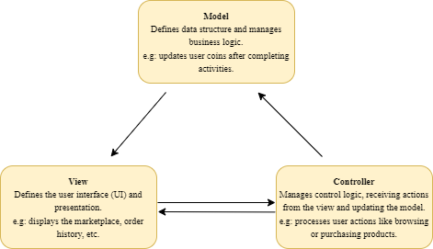

Architecturally Significant Design Packages
*Centralized System Controllers:
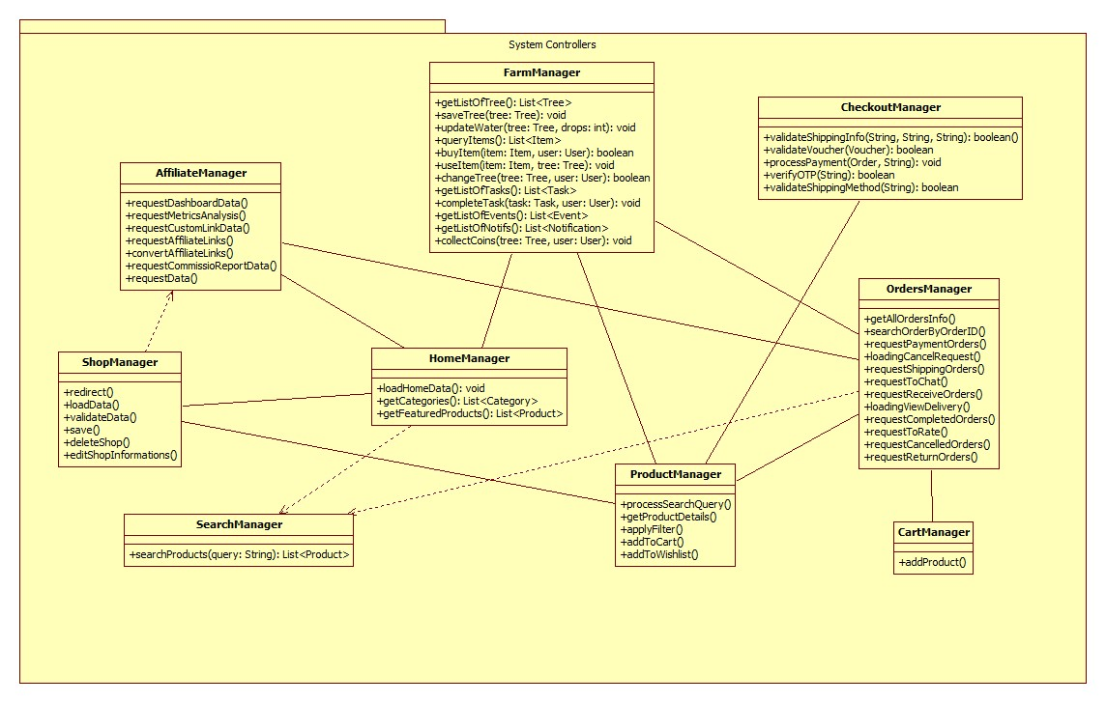
*System Data Models:
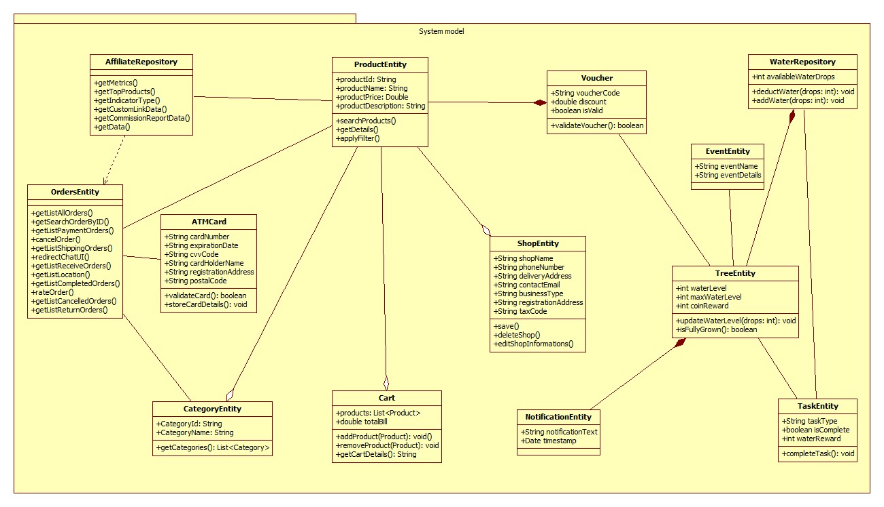
*User Interface View:
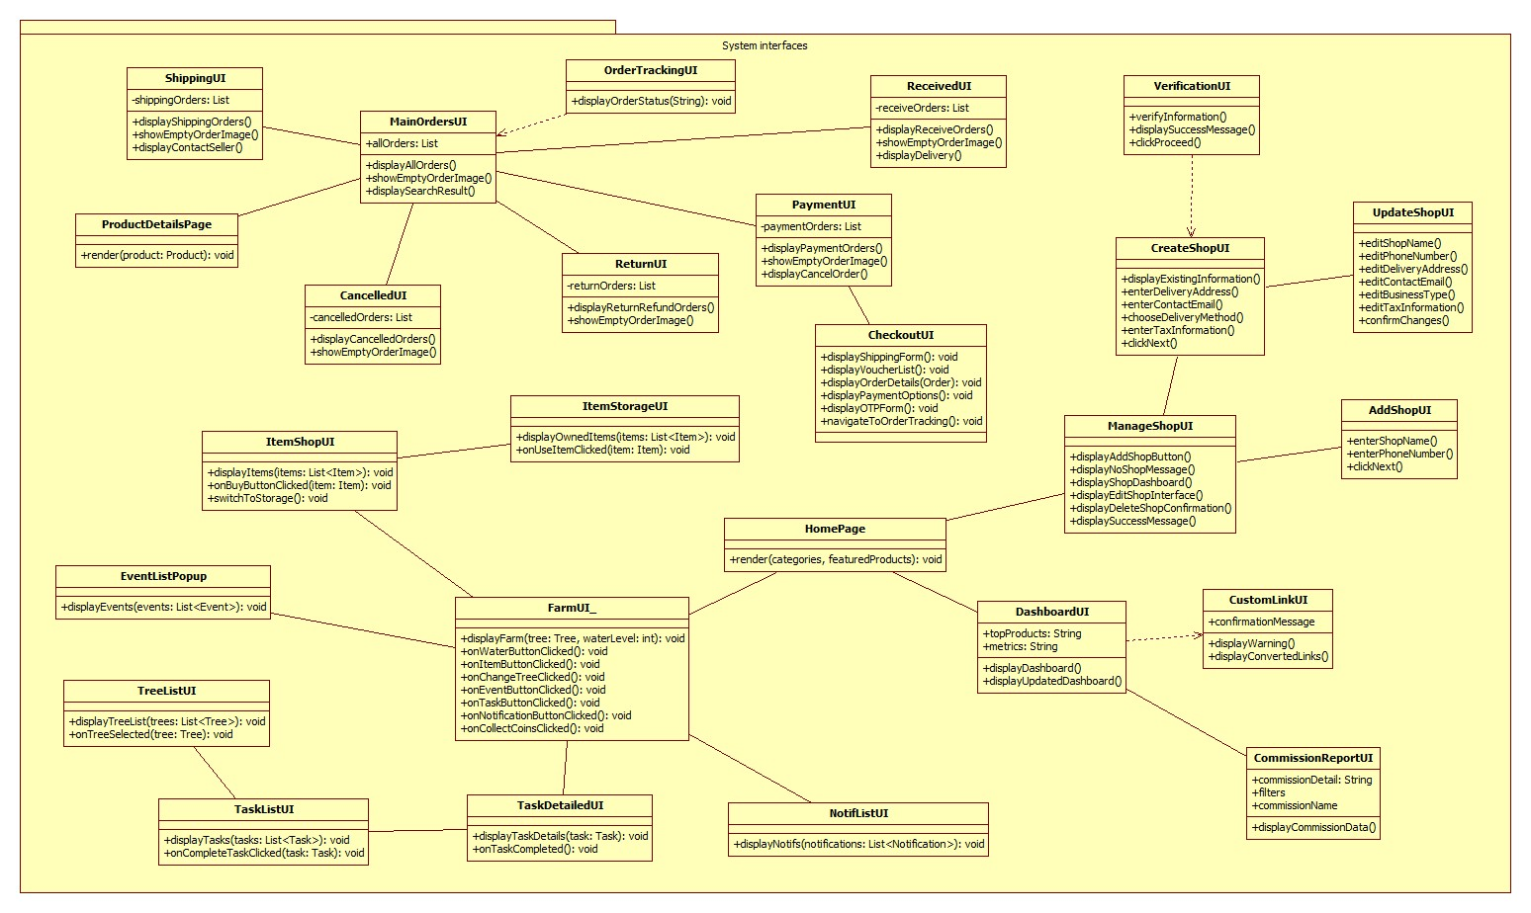

Process View
*View Products:
Users access the platform, browse product categories, or use the search bar to find desired items, applying sort and filter options to refine results. Selected products reveal detailed information, allowing users to add items to their cart or wishlist. The system processes these actions, ensuring seamless navigation and personalized user experience.
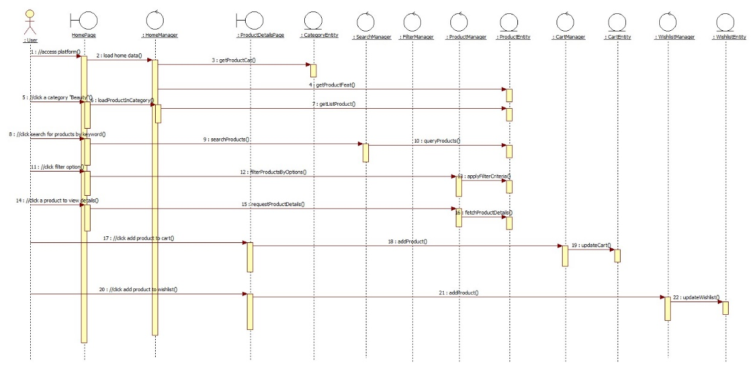
* Place Order
The user initiates the checkout process by clicking "Buy Now" and providing shipping details. The system validates the information, calculates costs, and updates the order summary. The user selects a shipping method, applies a voucher if available, and chooses a payment method. Finally, the user confirms the order, and the system processes payment and redirects to order tracking.
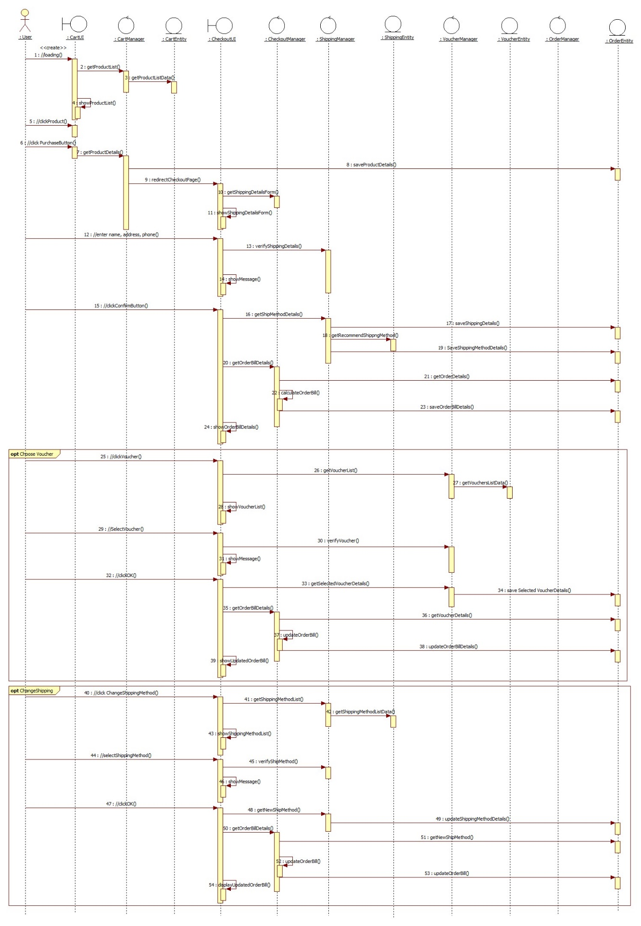
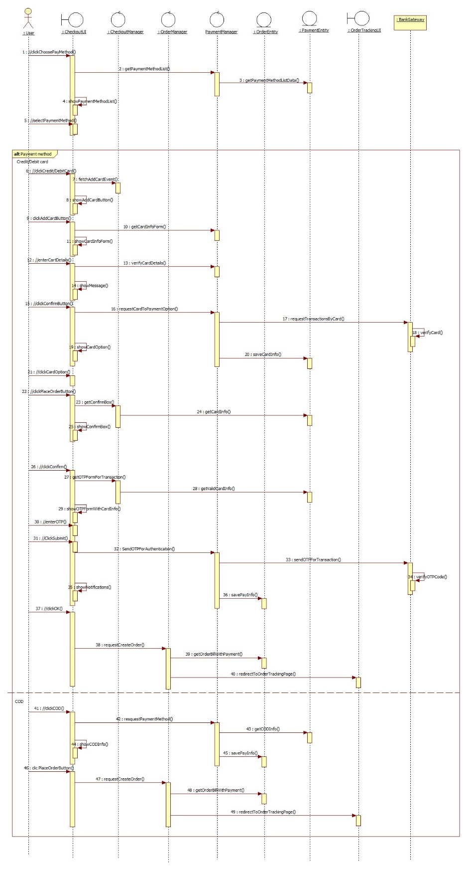

*Manage Orders
The user navigates to the MainOrders page to manage their orders, where all orders are retrieved and displayed. They can search for specific orders or filter by status using the navigation bar, with categories like All, To Pay, To Ship, To Receive, Completed, Cancelled, and Return Refund. Selecting a status retrieves and displays the corresponding orders, allowing users to perform actions such as canceling, contacting sellers, tracking shipments, providing feedback, or reviewing returned orders. Each action ensures relevant information and updates are reflected seamlessly across the interfaces.
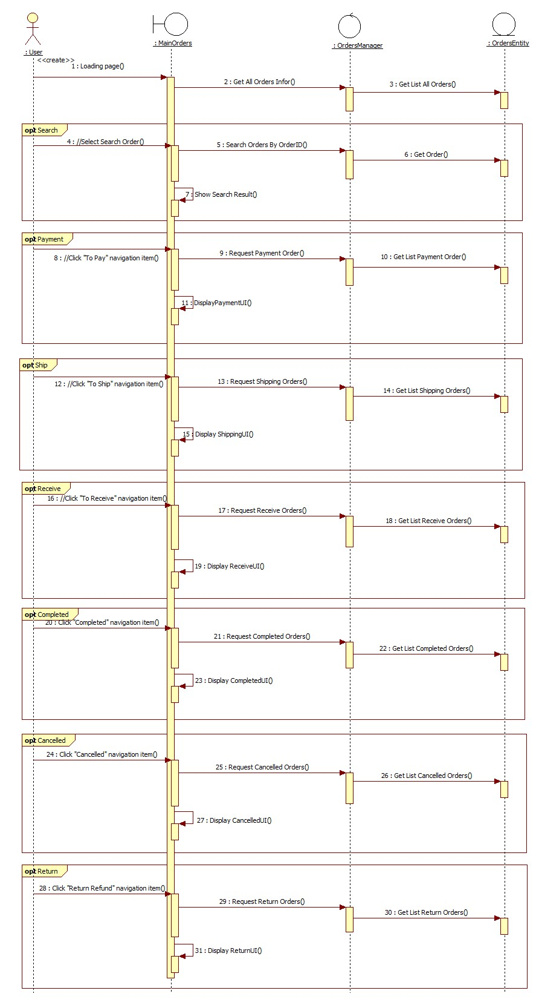
* Manage Shop
The user accesses the Shop Manager to create or manage their shop. If no shop exists, they are guided through a multi-step process to add shop details, select delivery methods, and provide tax information, with verification required to complete the setup. For existing shops, users can edit or delete shop information via options on the Shop Manager interface, following clear confirmation steps for changes or deletions. Successful actions update the interface accordingly.
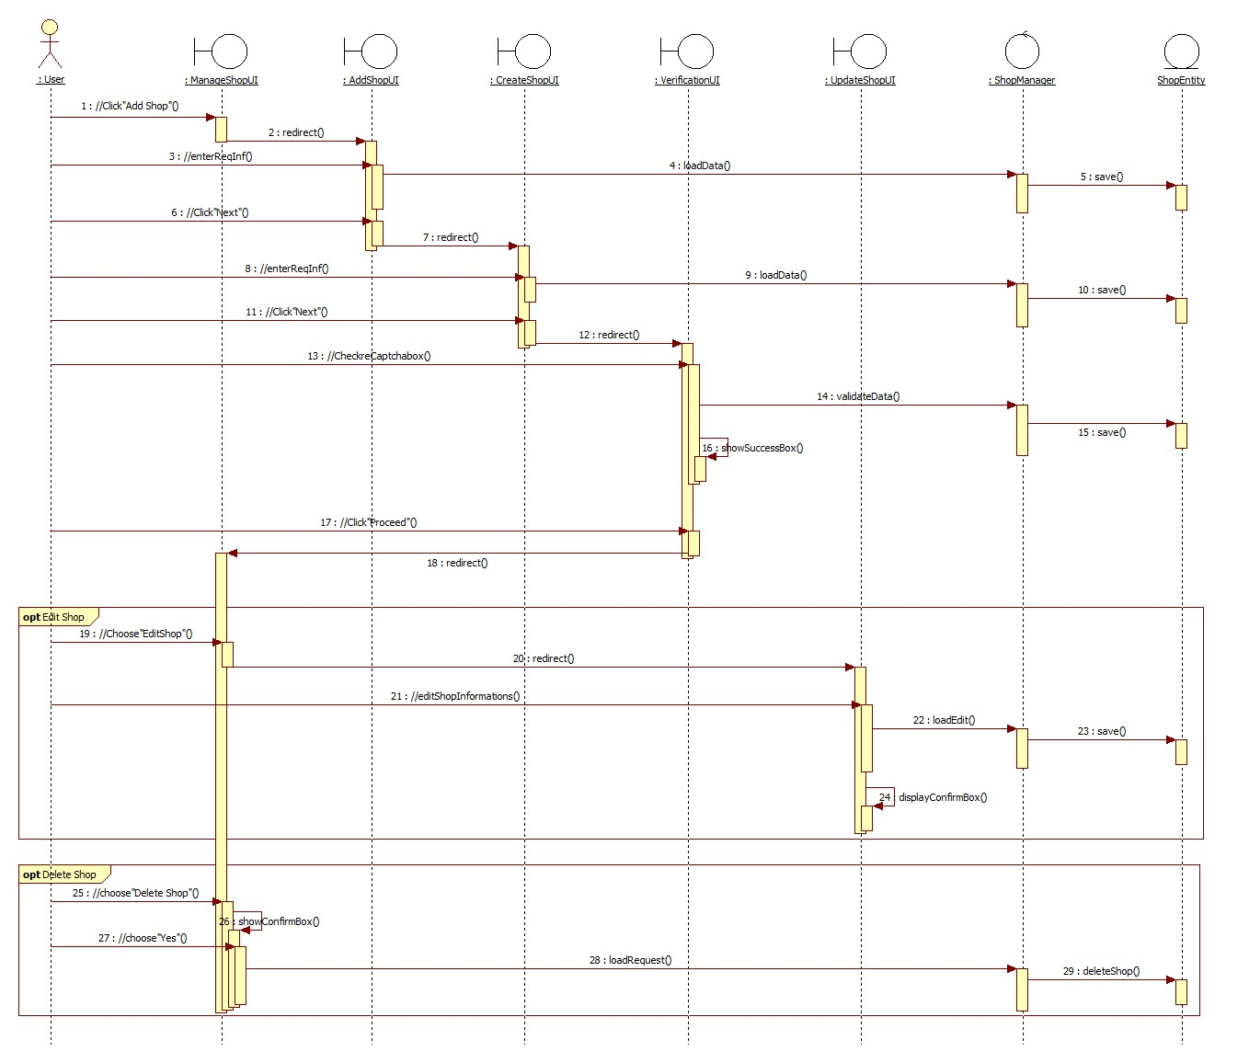
* Manage Affiliate Marketing
The user navigates between the Dashboard, Custom Link, and Commission Report sections via the header bar. Each section displays key metrics or functionalities, such as affiliate data summaries, custom affiliate link generation, and commission reporting, all with interactive filters and actionable options. Users can refine data, generate links, or review detailed reports with seamless navigation and confirmation prompts for successful actions.
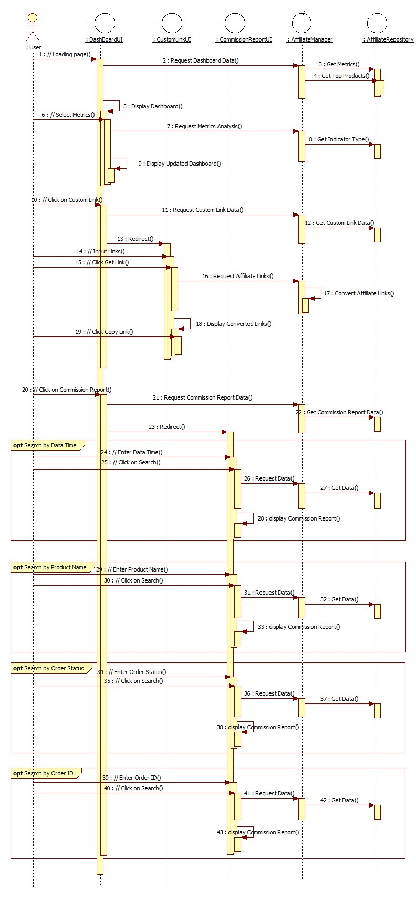

* Earn Coins
The user selects a tree, which is saved and displayed. They can water it, use items, or switch trees, with changes affecting inventory and coins. Tasks and events offer rewards, and users can play tree-planting games to earn coins, discount codes, and vouchers. Fully grown trees yield coins upon collection.
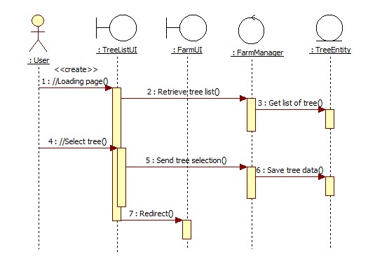
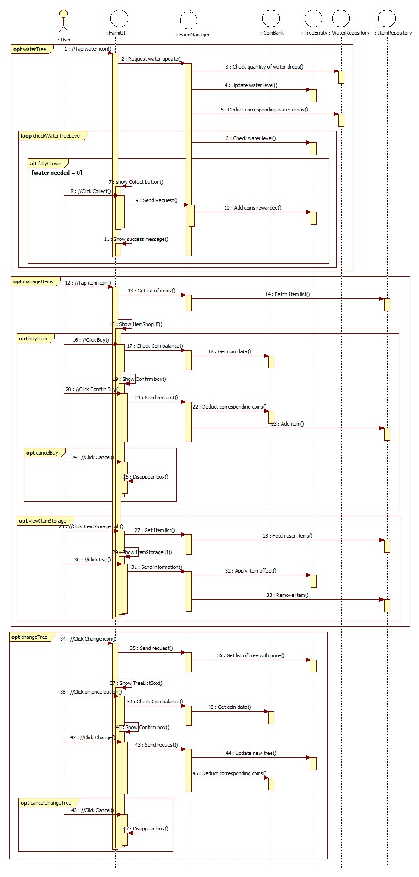
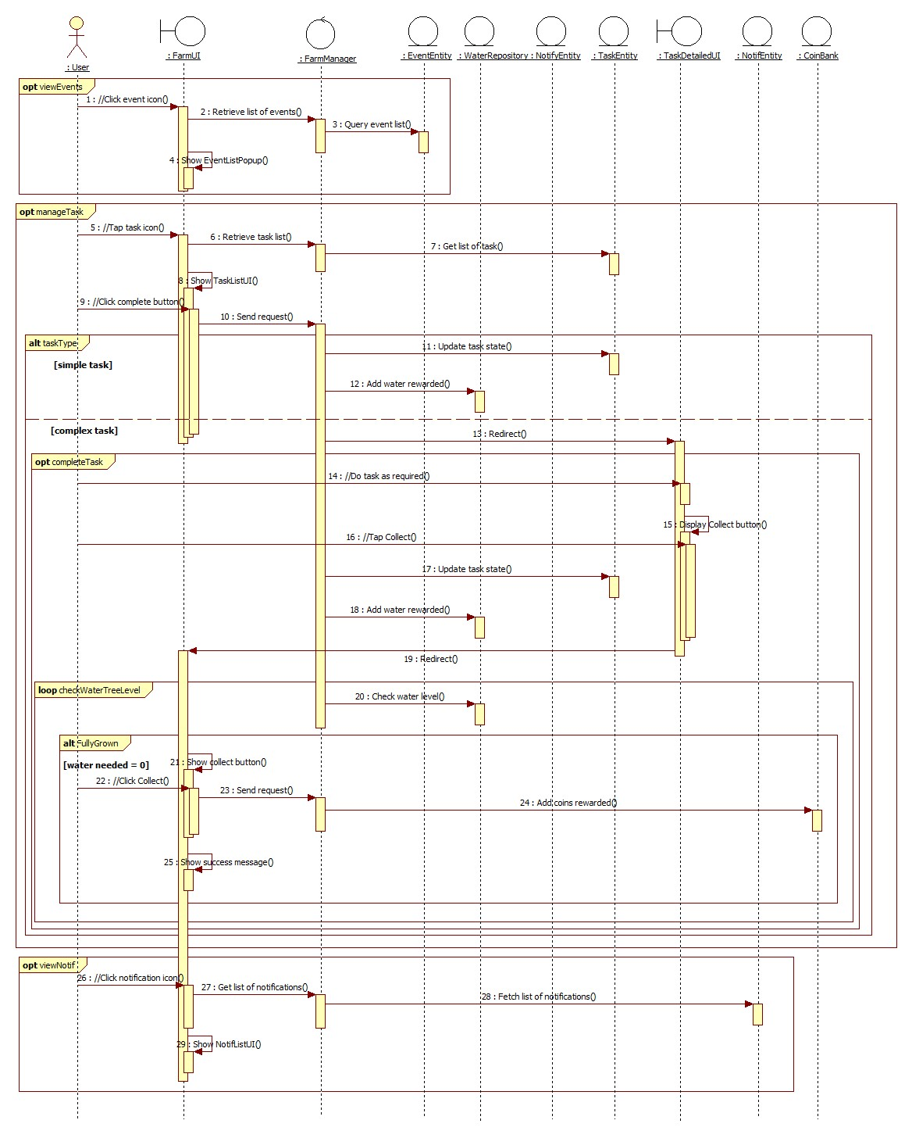

Deployment View
This e-commerce platform is hosted on a remote server, similar to platforms like Shopee, as it is a web-based application. Except for the generation of product models, most processes are handled on the backend, minimizing CPU usage on the client's side.

Implementation View
NA.

Data View (optional)
NA.

Size and Performance
Size
The Buy Ticket Platform is designed to handle an anticipated load of 10,000 users and 100,000 event listings. The platform should be able to handle peak traffic patterns of 1,000 concurrent users and 10,000 event searches per minute.

Performance Requirements

The platform should meet specific performance requirements, such as:

Response times: Users should experience minimal delays when interacting with the platform. Page load times should be under 2 seconds for most pages.

Transaction processing times: Ticket purchases and other transactions should be processed quickly and efficiently.

System availability: The platform should be highly available, with minimal downtime.

Performance Optimization

To achieve the desired performance, the platform should employ various optimization techniques, such as:

Caching: Frequently accessed data should be cached to reduce database load and improve response times.

Load balancing: Traffic should be distributed across multiple servers to prevent any single server from becoming overloaded.

Content Delivery Networks (CDNs): Static content, such as images and CSS files, should be served from CDNs to reduce load on the origin server.

Database optimization: Database queries should be optimized to minimize execution time and resource usage.

Code optimization: Code should be optimized for efficiency and minimize unnecessary processing.

Quality
The Buy Ticket Platform will adhere to the following quality attributes:

Security: Implement robust security measures to protect user data, prevent unauthorized access, and mitigate potential vulnerabilities. Employ techniques like encryption, access control, and vulnerability scanning.

Reliability: Ensure the platform's availability and minimize downtime through redundant infrastructure, load balancing, and effective monitoring and alerting systems.

Maintainability: Design the platform for ease of maintenance, using modular architecture, clear documentation, and well-established coding practices.

Testability: Design the platform with testability in mind, enabling unit, integration, and end-to-end testing to ensure the platform's functionality and quality.

